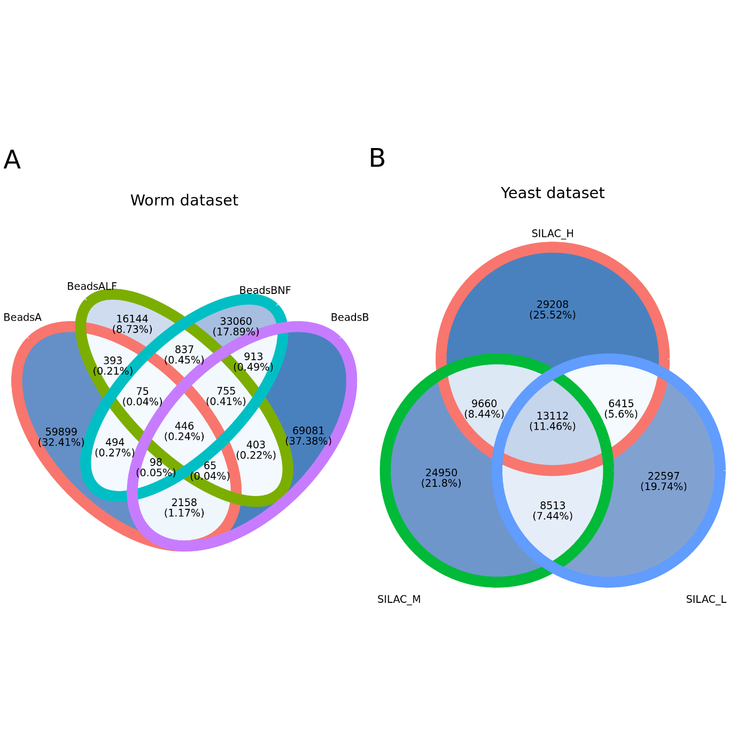
Fig. S1 The intersection of positive predictions for different data in (A) Worm and (B) Yeast datasets.

Table S1 The detailed layer architecture and hyperparameters of CNN in SPIFFED, using the yeast dataset as an example.
Layers | Output shape | Operation
Convolution | None × 1 × 26 × 128 | 2 × 2 conv, stride=1, ReLU
Flatten | None × 3328
Dense + Dropout | None × 30 | ReLU, dropout rate=0.2
Dense + Dropout | None × 20 | ReLU, dropout rate=0.2
Dense | None × 10 | ReLU
Dense | None × 5 | ReLU
Dense | None × 1 | Sigmoid

Table S2 Comparison of prediction performance on the human dataset, the yeast dataset and the worm dataset (see Material and Methods for dataset sources). For the evaluation of PrInCE, we have modified the tool [1] to allow changing the positive to negative ratio of training data (the modified version can be found at our Github fork of the PrInCE package: https://github.com/jinyung/PrInCE). We compared the performance of PrInCE, EPIC, and SPIFFED using the same positive to negative ratio of 1:5 for training data and the same five-fold cross-validation scheme. Other parameters of PrInCE were left at default values. PrInCE outputs two values (score and precision) for each protein-protein interaction (PPI) predictions, with precision as the default value used to report predicted labels. Because the score value is conceptually more similar to what EPIC and SPIFFED used to report predicted labels, we report the evaluation results for both values (by using cut-offs of score > 0.9 and precision > 0.5 as positive predictions). See Materials and Methods for detailed description of running parameters of EPIC, the definitions of testing data, and the formulas of evaluation metrics used.
Datasets |  | tool | type | Sensitivity | Accuracy | Precision | AUROC | AUPRC
Human dataset | condition1 | PrInCE | score > 0.9 | 0.401 | 0.915 | 0.296 | 0.773 | 0.309
 |  |  | precision > 0.5 | 0.256 | 0.945 | 0.500 | 0.773 | 0.307
 |  | EPIC | whole¹ | 1.000 | 1.000 | 1.000 | 1.000 | 1.000
 |  |  | testing | 0.345 | 0.865 | 0.692 | 0.780 | 0.540
 |  | SPIFFED | whole | 0.979 | 0.994 | 0.984 | 1.000 | 0.998
 |  |  | testing | 0.668 | 0.918 | 0.808 | 0.920 | 0.809
 | condition2 | PrInCE | score > 0.9 | 0.427 | 0.905 | 0.268 | 0.781 | 0.270
 |  |  | precision > 0.5 | 0.193 | 0.946 | 0.500 | 0.781 | 0.302
 |  | EPIC | whole | 0.999 | 1.000 | 1.000 | 1.000 | 1.000
 |  |  | testing | 0.367 | 0.870 | 0.715 | 0.800 | 0.560
 |  | SPIFFED | whole | 0.972 | 0.992 | 0.977 | 1.000 | 0.998
 |  |  | testing | 0.664 | 0.918 | 0.808 | 0.930 | 0.803
Yeast dataset | SILAC_H | PrInCE | score > 0.9 | 0.605 | 0.872 | 0.056 | 0.790 | 0.111
 |  |  | precision > 0.5 | 0.030 | 0.988 | 0.502 | 0.790 | 0.127
 |  | EPIC | whole | 1.000 | 1.000 | 1.000 | 1.000 | 1.000
 |  |  | testing | 0.407 | 0.872 | 0.703 | 0.830 | 0.597
 |  | SPIFFED | whole | 0.757 | 0.939 | 0.858 | 0.960 | 0.875
 |  |  | testing | 0.493 | 0.890 | 0.762 | 0.860 | 0.642
 | SILAC_M | PrInCE | score > 0.9 | 0.604 | 0.867 | 0.054 | 0.788 | 0.106
 |  |  | precision > 0.5 | 0.032 | 0.988 | 0.502 | 0.788 | 0.130
 |  | EPIC | whole | 1.000 | 1.000 | 1.000 | 1.000 | 1.000
 |  |  | testing | 0.419 | 0.875 | 0.713 | 0.830 | 0.600
 |  | SPIFFED | whole | 0.752 | 0.941 | 0.878 | 0.960 | 0.899
 |  |  | testing | 0.617 | 0.901 | 0.744 | 0.900 | 0.736
 | SILAC_L | PrInCE | score > 0.9 | 0.617 | 0.864 | 0.054 | 0.792 | 0.102
 |  |  | precision > 0.5 | 0.000 | 0.890 | 0.667 | 0.524 | 0.116
 |  | EPIC | whole | 1.000 | 1.000 | 1.000 | 1.000 | 1.000
 |  |  | testing | 0.402 | 0.870 | 0.688 | 0.830 | 0.590
 |  | SPIFFED | whole | 0.727 | 0.939 | 0.884 | 0.960 | 0.885
 |  |  | testing | 0.622 | 0.901 | 0.741 | 0.900 | 0.735
Worm dataset | beadsA | PrInCE | score > 0.9 | 0.152 | 0.927 | 0.038 | 0.588 | 0.025
 |  |  | precision > 0.5 | 0.005 | 0.985 | 0.609 | 0.589 | 0.034
 |  | EPIC | whole | 1.000 | 1.000 | 1.000 | 1.000 | 1.000
 |  |  | testing | 0.076 | 0.833 | 0.493 | 0.600 | 0.268
 |  | SPIFFED | whole | 0.656 | 0.922 | 0.843 | 0.910 | 0.799
 |  |  | testing | 0.328 | 0.832 | 0.493 | 0.710 | 0.421
 | beadsALF | PrInCE | score > 0.9 | 0.309 | 0.917 | 0.082 | 0.688 | 0.058
 |  |  | precision > 0.5 | 0.013 | 0.980 | 0.544 | 0.689 | 0.075
 |  | EPIC | whole | 1.000 | 1.000 | 1.000 | 1.000 | 1.000
 |  |  | testing | 0.408 | 0.865 | 0.653 | 0.810 | 0.569
 |  | SPIFFED | whole | 0.860 | 0.960 | 0.898 | 0.970 | 0.929
 |  |  | testing | 0.651 | 0.912 | 0.784 | 0.890 | 0.744
 | beadsB | PrInCE | score > 0.9 | 0.167 | 0.935 | 0.053 | 0.607 | 0.032
 |  |  | precision > 0.5 | 0.009 | 0.983 | 0.510 | 0.608 | 0.049
 |  | EPIC | whole | 1.000 | 1.000 | 1.000 | 1.000 | 1.000
 |  |  | testing | 0.157 | 0.845 | 0.647 | 0.660 | 0.384
 |  | SPIFFED | whole | 0.806 | 0.950 | 0.885 | 0.950 | 0.885
 |  |  | testing | 0.424 | 0.865 | 0.646 | 0.790 | 0.565
 | beadsBNF | PrInCE | score > 0.9 | 0.325 | 0.922 | 0.085 | 0.691 | 0.058
 |  |  | precision > 0.5 | 0.010 | 0.981 | 0.531 | 0.691 | 0.079
 |  | EPIC | whole | 1.000 | 1.000 | 1.000 | 1.000 | 1.000
 |  |  | testing | 0.414 | 0.873 | 0.698 | 0.820 | 0.603
 |  | SPIFFED | whole | 0.892 | 0.967 | 0.910 | 0.970 | 0.919
 |  |  | testing | 0.660 | 0.912 | 0.779 | 0.900 | 0.779
¹whole = training and testing splits combined. Reported values are means of all folds.

Table S3 Positive predictions meet the eligibility criteria for the three voting mechanisms in ensemble model when the number of data is four. At least one positive prediction out of four data were considered.
Predictions of data |  |  |  | Probability of positive predictions |  | Eligibility criteria
Data₁ | Data₂ | Data₃ | Data₄ | By occurrence | By data number | AA | MA | SMA
+ | NA | NA | NA | 1.0 | 0.25 | O | O | X
+ | + | NA | NA | 1.0 | 0.5 | O | O | O
+ | − | NA | NA | 0.5 | 0.25 | O | O | X
+ | + | + | NA | 1.0 | 0.75 | O | O | O
+ | + | − | NA | 0.66 | 0.5 | O | O | O
+ | − | − | NA | 0.33 | 0.25 | O | X | X
+ | + | + | + | 1.0 | 1.0 | O | O | O
+ | + | + | − | 0.75 | 0.75 | O | O | O
+ | + | − | − | 0.5 | 0.5 | O | O | O
+ | − | − | − | 0.25 | 0.25 | O | X | X

Supplement materials
Yeast datasets
Growth conditions for SILAC labeling and lysate preparation for size-exclusion chromatography. The budding yeast, Saccharomyces cerevisiae, cells (isogenic with W303) was grown overnight to log phase (OD600 = 0.5) at 23°C in synthetic medium containing 6.7 g/l yeast nitrogen base, 2% glucose, 80 mg/l each of L-alanine, L-asparagine, L-aspartic acid, L-cysteine, L-glutamic acid, L-glutamine, L-glycine, L-histidine, L-isoleucine, L-methionine, L-phenylalanine, L-proline, L-serine, L-threonine, L-tryptophan, L-tyrosine, L-valine, inositol, and uracil, 8 mg/l p-aminobenzoic acid, 400 mg/l L-leucine, and 20 mg/l adenine with the addition one of 20 mg/l heavy L-arginine (Arg, 4,4,5,5-D4 13C6, 15N; Thermo Fisher Scientific, Waltham, MA, USA) plus 30 mg/l heavy L-lysine (Lys, 13C6, 15N2; Cambridge Isotope Laboratories, Andover, MA, USA), 20 mg/l medium L-arginine (Arg, 13C6; Thermo Fisher Scientific, Waltham, MA, USA) plus 30 mg/l medium L-lysine (Lys, 4,4,5,5-D4; Cambridge Isotope Laboratories, Andover, MA, USA) and 20 mg/l light Arg plus 30 mg/l light Lys (Sigma-Aldrich). Then the cells were harvested, washed once with distilled water, and the cell pellets were kept at -80 °C before lysis. The Sc cells were grown in the heavy, medium and light medium independently. The cell pellets were resuspended in lysis buffer (20 mM HEPES-KOH pH 7.4, 120 mM KCl, 2 mM EDTA, 0.5 mM DTT, 10% glycerol) with 1 mM PMSF and protease inhibitor cocktail set IV (Merck, Darmstadt, Germany). The cells were frozen in liquid nitrogen and then lysed using a 6875 Freezer/Mill High Capacity Cryogenic Grinder (SPEX SamplePrep, Metuchen, NJ, USA). The lysate was thawed and cleared by centrifugation at 15,000 × g for 15 min at 4 °C, and then filtered using 0.45-μm syringe filters (Minisart NML Syringe Filter 16555K, Sartorius, Goettingen, Germany). The protein concentration of the cleared lysate was measured by the Bradford assay.
Size-exclusion chromatography (SEC). The same protein amounts of lysates from a Sc cell culture labeled with heavy Arg and Lys, a Sc cell culture labeled with medium Arg and Lys and another Sc cell culture labeled with light Arg and Lys were mixed, and then a total of 200 μl of lysate was injected into a Superose 6 10/300GL column (GE Life Sciences, Chicago, IL, USA) equilibrated with the lysis buffer on an ÄKTA Purifier system (GE Life Sciences). The flow rate was 0.2 ml/min, and 81 200-μl fractions were collected. We pooled every three sequential fractions into one new fraction, resulting in a total of 27 fractions.
Sample preparation for LC-MS/MS analysis. Proteins in the 27 SEC fractions (see above) were denatured by adding urea to a final concentration of 8 M, followed by reduction with 5 mM dithioerythritol at 37 °C for 45 min, and cysteine alkylation with 25 mM iodoacetamide at room temperature in the dark for 1 h. Protein samples were transferred to Amicon Ultra-0.5 centrifugal filters (10 kDa, Millipore, Burlington, MA, USA) and centrifuged at 13,200 × g for 20 min. Buffer exchange was performed in two successive washes with 8 M urea in 25 mM HEPES pH 7.4. Protein concentrations were then determined by the Bradford assay. Samples were digested overnight at 37 °C using LysC protease and trypsin at an enzyme-to-substrate ratio of 1:50 (w/w). Total peptide concentration was measured via Pierce quantitative colorimetric peptide assays (Thermo Fisher Scientific). Peptide desalting was achieved using C18 Stage Tips (Thermo Fisher Scientific), and 0.5 μg of the peptide from each sample was taken for LC-MS/MS analysis.

LC-MS/MS analysis. NanoLC-nanoESi-MS/MS analysis was performed on a Thermo UltiMate 3000 RSLCnano system connected to a Thermo Orbitrap Fusion mass spectrometer (Thermo Fisher Scientific) equipped with a nanospray interface (New Objective, Woburn, MA, USA). Peptide mixtures were loaded onto a 75 μm ID, 25 cm length PepMap C18 column (Thermo Fisher Scientific) packed with 2 μm particles having a pore width of 100 Å and they were separated for 150 min using a segmented gradient from 5% to 35% solvent B (0.1% formic acid in acetonitrile) at a flow rate of 300 nl/min. Solvent A was 0.1% formic acid in water. The mass spectrometer was operated in the data-dependent mode. Briefly, survey scans of peptide precursors from 350 to 1600 m/z were performed at a 120K resolution with a 2 × 105 ion count target. Tandem MS was performed by isolation window at 2 Da with the quadrupole, HCD fragmentation with normalized collision energy of 30, and rapid scan MS analysis in the ion trap. The MS2 ion count target was set to 104 and the max injection time was 50 ms. Only precursors with charge states of 2-6 were sampled for MS2. The instrument was run in top speed mode with 3 s cycles, and the dynamic exclusion duration was set to 60 s with a 10 ppm tolerance around the selected precursor and its isotopes. Monoisotopic precursor selection was turned on.
Data analysis of LC-MS/MS results. Mass spectrometry data were processed with MaxQuant software 81 (v. 1.6.7.0) according to a protocol described previously 82. Peptides and proteins were identified using the Andromeda search engine against the Sc protein sequence database with the following search parameters: carbamidomethylation of cysteine as a fixed modification; oxidation of methionine, deamidation of asparagine and glutamine, acetylation of protein N-termini, and trypsin cleavage with a maximum of two missed cleavages. The unique peptides were used for peptide quantification. To improve the number of peptides that could be used for protein quantification and relative abundance profiling across SEC fractions, the match between runs option was enabled with a matching window set to 0.7 min and an alignment window of 20 min. The re-quantify option was also enabled. The false discovery rate (FDR) of peptides and protein identification was set at 1%. All other MaxQuant parameters were left as the default options. All protein identifications were required to have at least one unique peptide.
For relative protein quantification, the extract ion current intensities reported by MaxQuant were used. The intensities in different fractions were corrected by multiplying by the peptide concentrations in the corresponding fractions.

References
- Skinnider MA, Cai C, R. Stacey RG, et al. PrInCE: an R/Bioconductor package for protein–protein interaction network inference from co-fractionation mass spectrometry data. Bioinformatics 2021:37: 2775–2777

